Project Proposal

**Group Members:** *Cathleen Yang, Zachary Fletcher, Devin Jaster, Wesley Booher, Derek Garibaldi*

**Business Problem:**

To introduce solutions on how students at the University of Utah implement their meal planning after moving off campus and away from campus dining meal plans.

**Problem Context:**

Students moving off campus face financial challenges related to meal planning. Research suggests that students living off campus spend an average of $410 per month on meals, with $250 of that amount going to groceries. In comparison, the average campus meal plan costs $335 per month[1]. Additionally, this comparison does not account for the time and effort required to cook and prepare meals.

The University of Utah offers many resources to its students for cost of food, meal planning, and meal prep, which is an important consideration when determining the best solutions for university students[2]. The university has partnered with numerous community, government, and nonprofit programs which offer food services and basic needs. The University of Utah also funds a few pantries and services of their own, including In A Pinch Pantry and Feed U pantries. These pastries require students and faculty to use their UnIDs[3]. The Feed U Feed you pastries are 3 on campus pastries which are free for student and faculty use and offer non-perishable, nutritious foods[4]. In a pinch Pantry is sponsored by the Office of Student Engagement, and basic needs for students and faculty. The University of Utah offers a meal planning service for both on and off campus students. Prices for meal plans range from $3417-$6642 a semester. Lastly, the university offers 10% student discounts for nearby restaurants, an on-campus cafeteria in the A.Ray Olpin Student Union Building, and several stores to buy food throughout the campus[5].

Place of residence greatly influences how students go about their diet. A study done on 219 college students in New York also highlights this issue. Out of the 219 students, 67% answered that they skipped at least one meal within the last week. Compared with the on-campus students in the study, the off-campus students frequently stated that ‘having no time to prepare’ was a main reason for meal skipping[6]. Another study also shows that over one third of college males and females reported that they do not have time for meal preparation, around 25% cite money as a barrier, and 23% of college males cite cooking skills as another.

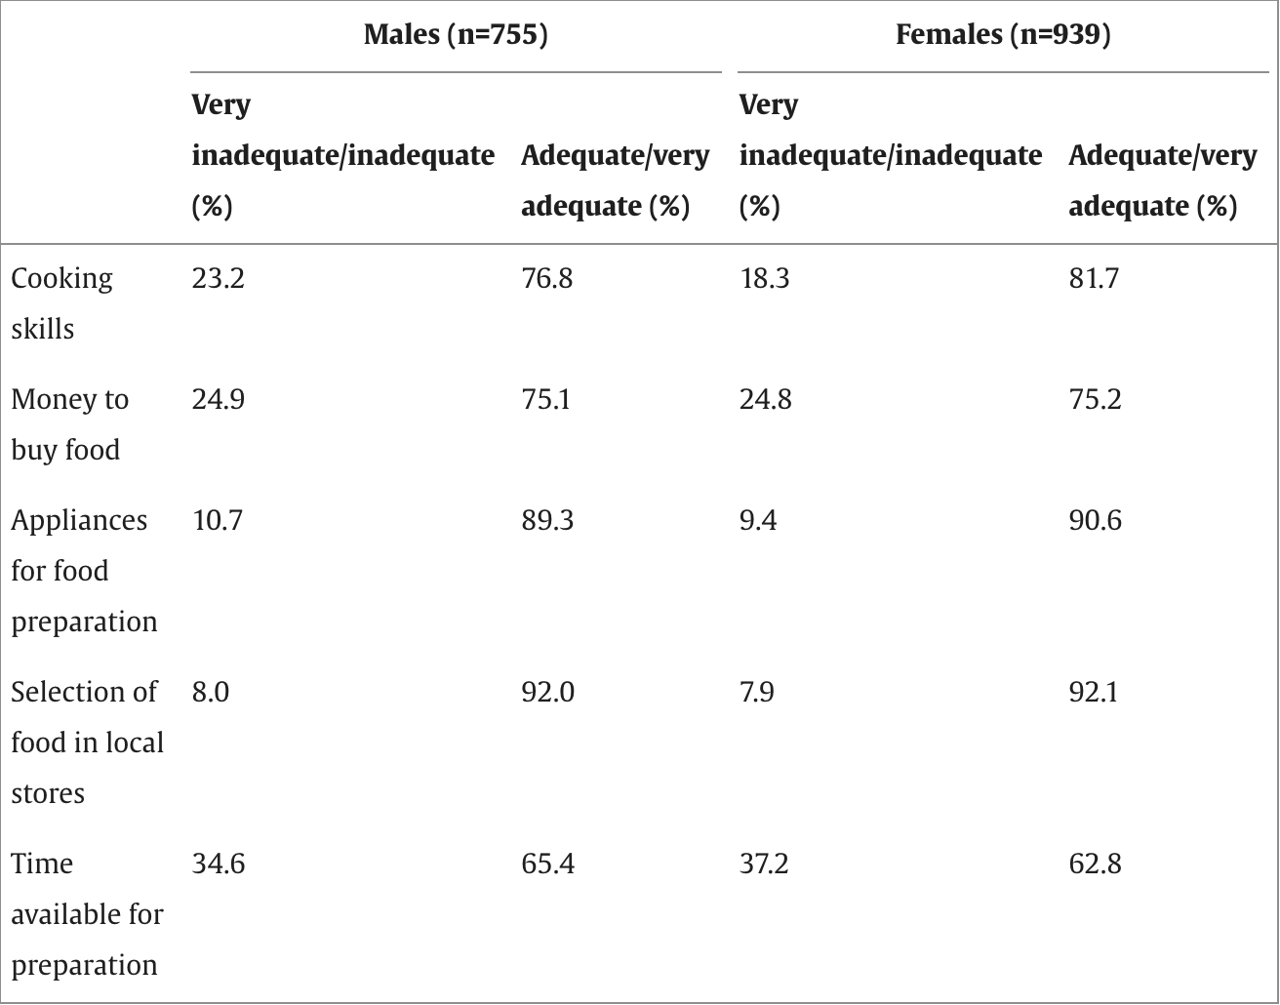

*Percentages of young adult participants in Project EAT (Eating Among Teens)-II who reported the adequacy of their skills and resources for food preparation were very inadequate/inadequate and adequate/very adequate*

By exploring the cost of meals off campus, existing university food programs, and behaviors of college students living off campus, we will be able to successfully evaluate a better way for students to eat while living off university grounds.

**Research Objective:**

The goal of this study will be to understand how students currently approach meal planning after moving off-campus and away from campus dining meal plans. Identify common challenges they face. Doing so will help us find areas where current solutions fall short or lack.

Research participants will be students of the University of Utah who have moved off campus and away from campus and have a dining meal plan. The idea is that we will learn from students who have recently transitioned from eating on campus to off-campus meal planning. It will also be essential to study different living arrangements which could include students living with roommates, family, or by themselves.

The information gained through our research will help our company design solutions that resonate with students pivoting from a campus meal plan to off-campus eating. The research will guide our company towards the friction points that off-campus students are feeling, thus helping us to improve their current options with restaurants and grocery stores.

**Value of Our Research:**

For Doing Research:

Benefits

* Gain a better understanding of college student eating habits, preferences, and finances regarding meal planning
* Understand the university resources allocated for student needs and whether these resources are helpful for students.
* Find trends where students would like to lower costs in their meal planning and eating habits
* Understand where students can have a better university meal experience, potentially driving consumption
* The cost of conducting interviews will be relatively $0.
* Identify barriers to meal planning of students who moved off-campus, such as affordability, lack of time, and convenience
* Identify gaps in current services that are provided for meal planning

Costs:

* Allocated time and resources to interviews
* Incentives for interviews may be needed for student participation
* May have to hire researchers or research firms to conduct market research.

Not Doing Research:

Benefits

* Saving resources, such as time and the need to get incentives for students to participate

Costs

* Lacking insight into students' current meal plans or the eating habits of students who have just moved off-campus
* Missing important chances to identify students' preferences for eating habits[7][8]

1. <https://educationdata.org/average-monthly-food-spend-college-student>
2. <https://healthcare.utah.edu/news/tags/meal-prep>
3. <https://eccles.utah.edu/programs/undergraduate/in-a-pinch/>
4. <https://basicneeds.utah.edu/food-resources.php>
5. <https://attheu.utah.edu/students/student-discounts-30/>
6. <https://koreascience.kr/article/JAKO202213650050297.pdf>
7. <https://educationdata.org/average-monthly-food-spend-college-student>
8. <https://basicneeds.utah.edu/2024_bnc_annual_report.pdf>